Division Nurse Access
- Username: div-nurse
- Pass: div-nurse
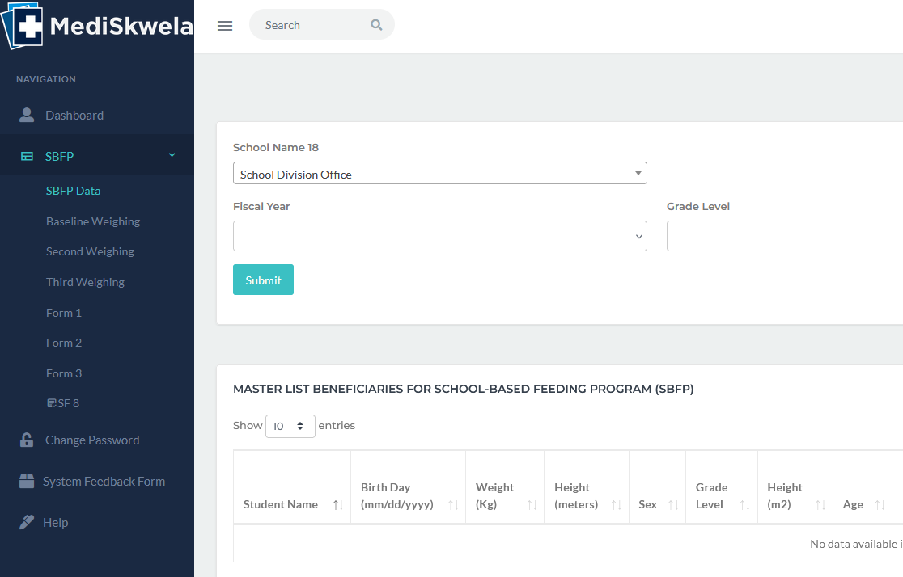
- School Name has a label 18
- Can’t select school. As division nurse, dapat access niya tanan schools for all reports

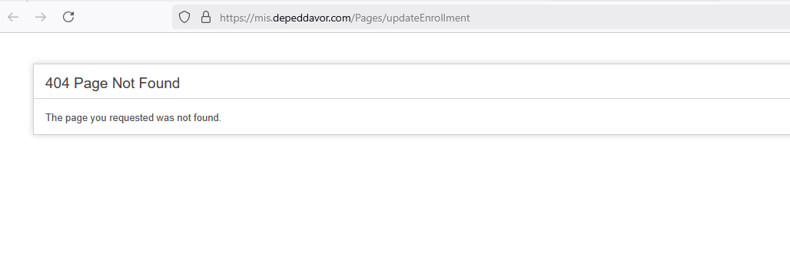
- Edit enrollment not yet uploaded

Please comment this on M and E access, irrelevant at this time.
